|  |
| --- |
| Student Attendance Tracker |
| Installation Guide |
|  |
| This document describes all the installation process one has to follow to use student attendance tracking system. This document covers all aspects of installation including various software’s needed, and how to deploy them on your machine. |
| Contents  [2 INTRODUCTION 3](#_Toc500445108)  [3 Git Server Installation 4](#_Toc500445109)  [3.1 Installing on Linux 5](#_Toc500445110)  [3.2 Installing on Mac 5](#_Toc500445111)  [3.3 Installing on Windows 6](#_Toc500445112)  [3.4 Installing from Source 7](#_Toc500445113)  [3.5 Testing the Installation 8](#_Toc500445114)  [4 How to Download and Setup Xcode 8 for iOS Development 8](#_Toc500445115)  [4.1 Step 0: Check your mac OS Version 9](#_Toc500445116)  [4.2 Step 1: Open the App Store 11](#_Toc500445117)  [4.3 Step 2: Search for XCode 11](#_Toc500445118)  [4.4 Step 3: Install Xcode 11](#_Toc500445119)  [4.5 Step 4: Launch Xcode 12](#_Toc500445120)  [4.5.1 Step 5: Register as an iOS Developer (optional) 12](#_Toc500445121)  [4.5.2 Troubleshooting 12](#_Toc500445122)  [4.5.3 All Set 13](#_Toc500445123)  [5 Node Installation: 13](#_Toc500445124)  [5.1 On Windows: 13](#_Toc500445125)  [5.1.1 Step 0: The Quick Guide (TL;DR) to Get Node.js Installed on Windows 13](#_Toc500445126)  [5.1.2 Step 1: Download the Node.js .msi Installer 14](#_Toc500445127)  [5.1.3 Step 2: Run the Node.js Installer 14](#_Toc500445128)  [5.1.4 Step 3: Verify that Node.js was Properly installed 15](#_Toc500445129)  [5.1.5 Step 4: Update the Local npm Version 15](#_Toc500445130)  [5.2 On Mac: 15](#_Toc500445131)  [5.2.1 Prerequisites 15](#_Toc500445132)  [5.2.2 Why Homebrew? 16](#_Toc500445133)  [5.2.3 Installation 17](#_Toc500445134)  [5.2.4 How to Update Node and NPM 17](#_Toc500445135)  [5.2.5 How to Uninstall Nosde and NPM 17](#_Toc500445136)  [6 Installing the Student Application – IOS Application on the IPHONE. 18](#_Toc500445137)  [6.1 Installation Steps: 18](#_Toc500445138) |

Student Attendance Tracker

Installation Guide

# INTRODUCTION

1.1 PURPOSE

THE PURPOSE OF THIS DOCUMENT is to guide the user with installations of software; which are required to run “Student Attendance Tracker” web application and mobile application.

1.2 REVISION HISTORY

The revision history table shows who has worked on this document, the recent modifications and when the changes are made and description of the changes against each version of change.

|  |  |  |  |
| --- | --- | --- | --- |
| Version No | Version date | Description | Author |
| 1 | 12/01/2017 | First Draft | Sirisha Vanamali |
|  |  |  |  |

1.3 TECHNICAL PROJECT STAKEHOLDERS

This section mentions all the members who are interested and have vested their time in the project.

|  |  |
| --- | --- |
| **Team Member** | **Role and Responsibility** |
| Sirisha Vanamali | Primary Contact |
| Vamshi Devalla | Quality and Test Management |
| Rohith Babu Sadhu | Client Management |
| Sai Ram Mamidala | Data Management |
| Subba Reddy Pothireddy | Issue Management |
| Vipul Reddy Madadi | Requirements Management |
| Shankar Rao Vallapurapu | Comm and Doc Management |

1.4 Definitions, Acronyms and abbreviations

|  |  |
| --- | --- |
|  |  |
|  |  |
|  |  |
|  |  |
|  |  |
|  |  |
|  |  |
|  |  |

# Git Server Installation

**Prerequisites:** Check your computer Configurations before you proceed with server installations. Make sure you download the proper git server as it’s different for a 32-bit and a 64-bit operating systems.

## Installing on Linux

If you want to install the basic Git tools on Linux via a binary installer, you can generally do so through the basic package-management tool that comes with your distribution. If you’re on Fedora for example (or any closely-related RPM-based distro such as RHEL or CentOS), you can use dnf:

$ sudo dnf install git-all

If you’re on a Debian-based distribution like Ubuntu, try apt-get:

$ sudo apt-get install git-all

For more options, there are instructions for installing on several different Unix flavors on the Git website, at <http://git-scm.com/download/linux>.

## Installing on Mac

There are several ways to install Git on a Mac. The easiest is probably to install the Xcode Command Line Tools. On Mavericks (10.9) or above you can do this simply by trying to run *git* from the Terminal the very first time. If you don’t have it installed already, it will prompt you to install it.

If you want a more up to date version, you can also install it via a binary installer. A macOS Git installer is maintained and available for download at the Git website, at <http://git-scm.com/download/mac>.

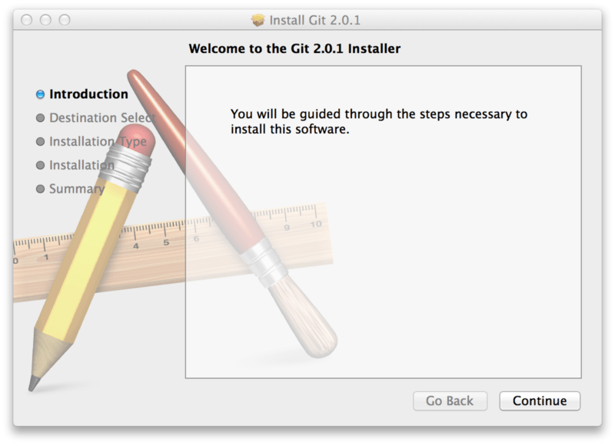

Figure 1. Git macOS Installer.

You can also install it as part of the GitHub for Mac install. Their GUI Git tool has an option to install command line tools as well. You can download that tool from the GitHub for Mac website, at <http://mac.github.com>.

## Installing on Windows

There are also a few ways to install Git on Windows. The most official build is available for download on the Git website. Just go to <http://git-scm.com/download/win> and the download will start automatically. Note that this is a project called Git for Windows, which is separate from Git itself; for more information on it, go to <https://git-for-windows.github.io/>.

To get an automated installation you can use the [Git Chocolatey package](https://chocolatey.org/packages/git). Note that the Chocolatey package is community maintained.

Another easy way to get Git installed is by installing GitHub for Windows. The installer includes a command line version of Git as well as the GUI. It also works well with Powershell, and sets up solid credential caching and sane CRLF settings. We’ll learn more about those things a little later, but suffice it to say they’re things you want. You can download this from the GitHub for Windows website, at <http://windows.github.com>.

## Installing from Source

Some people may instead find it useful to install Git from source, because you’ll get the most recent version. The binary installers tend to be a bit behind, though as Git has matured in recent years, this has made less of a difference.

If you do want to install Git from source, you need to have the following libraries that Git depends on: autotools, curl, zlib, openssl, expat, and libiconv. For example, if you’re on a system that has dnf (such as Fedora) or apt-get (such as a Debian-based system), you can use one of these commands to install the minimal dependencies for compiling and installing the Git binaries:

$ sudo dnf install dh-autoreconf curl-devel expat-devel gettext-devel \

openssl-devel perl-devel zlib-devel

$ sudo apt-get install dh-autoreconf libcurl4-gnutls-dev libexpat1-dev \

gettext libz-dev libssl-dev

In order to be able to add the documentation in various formats (doc, html, info), these additional dependencies are required (Note: users of RHEL and RHEL-derivatives like CentOS and Scientific Linux will have to [enable the EPEL repository](https://fedoraproject.org/wiki/EPEL#How_can_I_use_these_extra_packages.3F) to download the docbook2X package):

$ sudo dnf install asciidoc xmlto docbook2X getopt

$ sudo apt-get install asciidoc xmlto docbook2x getopt

Additionally, if you’re using Fedora/RHEL/RHEL-derivatives, you need to do this

$ sudo ln -s /usr/bin/db2x\_docbook2texi /usr/bin/docbook2x-texi

due to binary name differences.

When you have all the necessary dependencies, you can go ahead and grab the latest tagged release tarball from several places. You can get it via the kernel.org site, at <https://www.kernel.org/pub/software/scm/git>, or the mirror on the GitHub website, at <https://github.com/git/git/releases>. It is generally a little clearer what the latest version is on the GitHub page, but the kernel.org page also has release signatures if you want to verify your download.

Then, compile and install:

$ tar -zxf git-2.0.0.tar.gz

$ cd git-2.0.0

$ make configure

$ ./configure --prefix=/usr

$ make all doc info

$ sudo make install install-doc install-html install-info

After this is done, you can also get Git via Git itself for updates:

$ git clone git://git.kernel.org/pub/scm/git/git.git

Source: https://git-scm.com/book/en/v2/Getting-Started-Getting-Help

## Testing the Installation

1. Follow the prompts to install Git.
2. Open a terminal and verify the installation was successful by typing git --version:

$ git --version

git version 2.9.2 ( should be the output ).

# How to Download and Setup Xcode 8 for iOS Development

Youtube Link: https://www.youtube.com/watch?v=Bgh9u7x8i4Y

Source: https://blog.londonappbrewery.com/how-to-download-and-setup-xcode-8-for-ios-development-e8a945219029



This tutorial is also available as a [step-by-step video tutorial](https://www.youtube.com/watch?v=4HH-ZHe4Hgg&list=PLSzsOkUDsvduhz8Rg1bgQm9ulQWZf2Fv7&index=3).

## Step 0: Check your mac OS Version

We will be using the latest version of Apple’s **Xcode 8** to program iOS apps and run our apps in Xcode’s built in iOS simulator.

Xcode is an Integrated Development Environment (IDE) developed by Apple and the vast majority of iOS developers rely on it for making iPhone or iPad applications. Xcode 8 has a minimum system requirement of OS X 10.11.5 or above (El Capitan) or ideally you should be running macOS Sierra (10.12).

If you are still running an earlier OS such as Mavericks, Yosemite etc, you will need to update your OS. Have a look on [Apple’s website](http://www.apple.com/uk/osx/whats-new/) for instructions on how to do so.

To check your current OS version, go to the apple icon at the top left of your Mac 🍎 → About This Mac

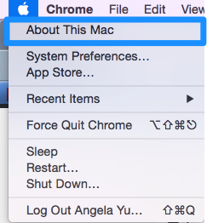

You should see a screen similar to this:

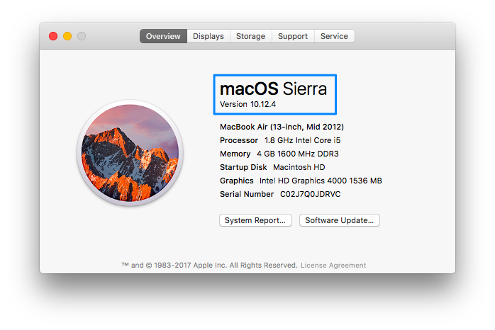

Check the OS is either El Capitan 10.11.**5** or above or macOS Sierra 10.12. If your version is lower than this, head over to the mac App Store and you can upgrade your operating system to macOS Sierra for free.

## Step 1: Open the App Store

Once you’re sure you are running the correct version of the mac operating system, you can get started with downloading Xcode 8 through the Mac App Store. Open the App Store app on your Mac. By default the App Store is in the Dock. You can also find it in your Launchpad.

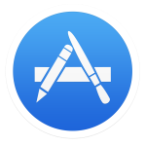

## Step 2: Search for XCode

In the search field in the top-right corner, type Xcode and press the Return key.

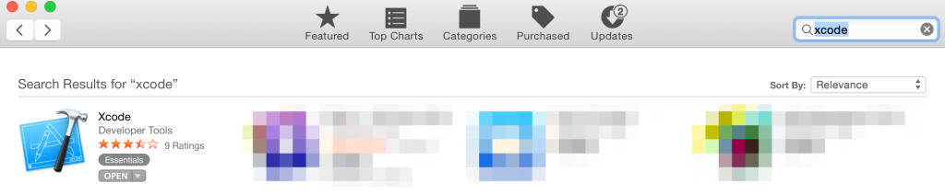

## Step 3: Install Xcode

Xcode is a free application developed by Apple, so just click the “Get” button



and start the installation process. Xcode is several gigabytes in size so downloading it could take a while. Xcode is downloaded into your **/Applications** directory.

## Step 4: Launch Xcode

Launch Xcode. Do you see the Welcome to Xcode window and the version is 8.0 or above? If yes, great. We’re all done!

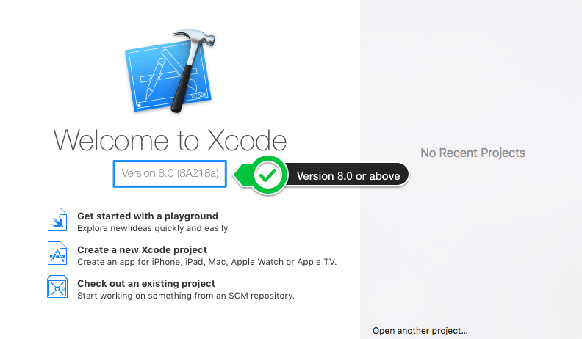

### Step 5: Register as an iOS Developer (optional)

Once you’re ready to submit apps to the App Store, you will need to enrol for the iOS Developer Program.

You can obtain a developer license from Apple and it costs $99 per year. Unless you are ready to release your app to the App Store and start clawing back that fee, it is not recommended to start paying Apple right away. But when you are ready to start the registration process, go to the [iOS Developer Program Center](https://developer.apple.com/programs/) and enrolment should only take a few minutes.

### Troubleshooting

These are some of the ways installation can go wrong. If you’re having problems, check if one of these fixes help to solve your problem.

* You don’t have enough **space** on your Mac hard-drive. Xcode is a large piece of software, make sure you have at least **10GB** free on your hard-drive before attempting installation.
* You have an earlier version of **OSX** installed. Xcode 8 can only be installed on a Mac running El Capitan (OS X 10.11.**5** or **macOS Sierra**). Go back to Step 0 and check to make sure you have upgraded to macOS Sierra as your operating system before you attempt to install Xcode. You can update your OS through the Mac App Store for free or check out Apple’s website for more details. [www.apple.com/uk/osx/whats-new/](http://www.apple.com/uk/osx/whats-new/)
* Please do not install a **beta** version of Xcode as it will impact installation of your apps on to a physical device. Follow our instructions above and you should have no problems.

This tutorial is also available as a [step-by-step video tutorial](https://www.youtube.com/watch?v=4HH-ZHe4Hgg&list=PLSzsOkUDsvduhz8Rg1bgQm9ulQWZf2Fv7&index=3).

### All Set

If you’ve completed all the above steps then you’re all set for your course. We look forwards to seeing you online or in-person. Remember, you can always hit our team up over Slack if you run into any other issues. (You’ll get your Slack invite in your inbox pretty soon).

# Node Installation:

## On Windows:

### Step 0: The Quick Guide (TL;DR) to Get Node.js Installed on Windows

Here's the abbreviated guide, highlighting the major steps:

Open the official page for [Node.js downloads](https://nodejs.org/en/download/) and download Node.js for Windows by clicking the "Windows Installer" option

Run the downloaded Node.js .msi Installer - including accepting the license, selecting the destination, and authenticating for the install.

This requires Administrator privileges, and you may need to authenticate

To ensure Node.js has been installed, run node -v in your terminal - you should get something like v6.9.5

Update your version of npm with npm install npm --global

This requires Administrator privileges, and you may need to authenticate

Congratulations - you've now got Node.js installed, and are ready to start building!

### Step 1: Download the Node.js .msi Installer

As the first step to installing Node.js on Windows, you'll need to download the installer. You'll be able to grab the installer from the [official downloads page for Node.js](https://nodejs.org/en/download/).

You'll be able to download the Windows Node.js installer by clicking the Windows Installer option at the top of the page - when you click this, you'll get an MSI installer download. Make sure to save it somewhere that you'll be able to find it!

### Step 2: Run the Node.js Installer

You've got the Windows Installer - great! Now, you need to install it on your PC. The installer is a pretty typical Wizard interface for installing software on Windows - there are a few steps to it, but you can have it done in under a minute. You can get through it by following the guide below:

Welcome to the Node.js Setup Wizard

Select Next

End-User License Agreement (EULA)

Check I accept the terms in the License Agreement

Select Next

Destination Folder

Select Next

Custom Setup

Select Next

Ready to install Node.js

Select Install

*Note:* This step requires Administrator privlidges.

If prompted, authenticate as an Administrator

Installing Node.js

Let the installer run to completion

Completed the Node.js Setup Wizard

Click Finish

### Step 3: Verify that Node.js was Properly installed

To double check that Node.js was installed fully on your PC, you can test the following command in your Command Prompt (regardless of if you're using cmd.exe, Powershell, or any other command prompt):

$ node -v

If Node.js was installed fully, the command prompt will print something similar to (but probably not exactly) this:

$ node -v // The command we ran - prints out the version of Node.js that's currently installed

v6.9.5 // The printed version of Node.js that's currently installed - v6.9.5 was the most current LTS release at the time of writing.

### Step 4: Update the Local npm Version

As the final step in getting Node.js installed, we'll update your version of npm - the package manager that comes bundled with Node.js.

Node.js always ships with a specific version of npm - Node.js doesn't (and shouldn't!) automatically update npm. The release cycle of the npm CLI client isn't in sync with the Node.js releases. Because of this, there's almost *certainly* going to be a newer version of npm available than the one that is installed as a default in any given Node release.

To quickly and easily update npm, you can run the following command:

npm install npm --global // Update the `npm` CLI client

Source: http://nodesource.com/blog/installing-nodejs-tutorial-windows/

## On Mac:

### Prerequisites

Before you install Node.js and NPM you’ll first need to have some familiarity with the Mac Terminal application. Terminal lets you dig into the underbelly of the operating system and issue text commands to your computer. You’ll need to use Terminal (or a similar application like [iTerm](http://iterm.sourceforge.net/)) to not only install Node.js but also to use it and NPM.

Before you can install Node, you’ll need to install two other applications. Fortunately, once you’ve got these on your machine, installing Node takes just a few minutes.

**XCode.** Apple’s XCode development software is used to build Mac and iOS apps, but it also includes the tools you need to compile software for use on your Mac. XCode is free and you can find it in the [Apple App Store](https://itunes.apple.com/us/app/xcode/id497799835?mt=12).

1. **Homebrew**. Homebrew is a package manager for the Mac — it makes installing most open source sofware (like Node) as simple as writing brew install node. You can learn more about Homebrew at the [Homebrew website](http://brew.sh/). To install Homebrew just open Terminal and type ruby -e "$(curl -fsSL https://raw.githubusercontent.com/Homebrew/install/master/install)". You’ll see messages in the Terminal explaining what you need to do to complete the installation process.

### Why Homebrew?

Observant readers will notice in the screenshot above that there’s an installer for NodeJS. You can download it directly from [NodeJS.org](http://nodejs.org). I recommend Homebrew over that installer for a few reasons:

1. When installing Node via the installer, you have to use the sudo command to make sure it installs properly (there is a workaround for this, but it’s complicated). sudo lets the installer place files in areas of your file system that are only accessible to administrators. One nice thing about Homebrew is that it doesn’t require access to administrator-only areas of your computer in order to install NodeJS (or any other package). This is a safer approach as it makes sure that any package you install with Homebrew can’t wreak havoc on your computer.
2. After installing Node via the installer you have to add the path to the node executable to your system $PATH. This involves mucking around with your shell login file. For experienced Terminal users or Unix-people this isn’t a big deal, but for those new to the command line that step can be daunting. Although the Homebrew method involves installing several different pieces of software, it’s generally just a simple process of point-click-and-wait. It takes a bit longer this way but there’s less room for error.
3. Homebrew is a great tool for web developers. First, it makes removing Node very easy (otherwise you have to crawl through your file system and delete a bunch of files manually). Second, it greatly simplfies the installation of other useful packages like Git, Ruby, or the very useful [wget](http://www.gnu.org/software/wget/) utility.

### Installation

Installing Node.js and NPM is pretty straightforward using Homebrew. Homebrew handles downloading, unpacking and installing Node and NPM on your system. The whole process (after you have XCode and Homebrew installed) should only take you a few minutes.

1. **Open the Terminal app** and type brew install node.
2. **Sit back and wait.** Homebrew downloads some files and installs them. And that’s it.

To make sure you have Node and NPM installed, run two simple commands to see what version of each is installed:

* To see if Node is installed, type node -v in Terminal. This should print the version number so you’ll see something like this v0.10.31.
* To see if NPM is installed, type npm -v in Terminal. This should print the version number so you’ll see something like this 1.4.27

[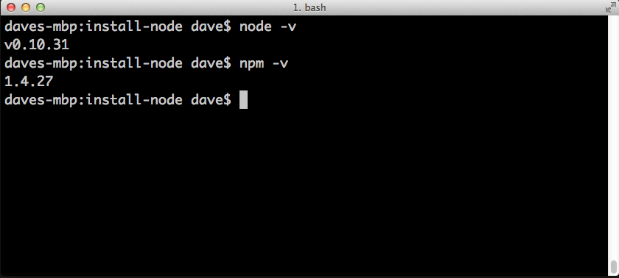](http://blog.teamtreehouse.com/wp-content/uploads/2014/10/node-install1.png)

### How to Update Node and NPM

* New versions of Node and NPM come out frequently. You can use Homebrew to update the software it installs.
* Make sure Homebrew has the latest version of the Node package. In Terminal type brew update
* Upgrade Node: brew upgrade node

### How to Uninstall Nosde and NPM

You can use Homebrew to uninstall packages that it installed: brew uninstall node

With Node.js and NPM installed you’ll soon be able to take advantage of the huge world of NPM modules that can help with a wide variety of tasks both on the web server and on your desktop (or laptop) machine. [The NPM site](https://www.npmjs.org/) lists all of the official Node packages making it easy to make the choice. Have fun and check out my [current courses at Treehouse.](http://teamtreehouse.com/davemcfarland)

Source: http://blog.teamtreehouse.com/install-node-js-npm-mac

# Installing the Student Application – IOS Application on the IPHONE.

Pre-requisites: The mobile needs to be having an iOS version minimum of OS X 10.11.5 or above (El Capitan) or ideally you should be running macOS Sierra (10.12). This application does not work on the latest versions starting from 11.x. This is a limitation of our application.

You also need a Mac system running XCode 8 to unzip the mobile application and deploy it on the mobile.

## Installation Steps:

# Extract the zip file on the MAC system. Check for the folder named QR.

Open the folder and check for the file which looks like so and double click on it.

# C:\Users\s528176\Downloads\Screen Shot 2017-12-06 at 7.04.13 PM.png

Now click on the folder icon the left hand top corner and then click on QRCodeReader.

C:\Users\s528176\Downloads\Screen Shot 2017-12-06 at 7.10.37 PM.png

Now click on the version of the ios in your mobile that you are going to install the application.

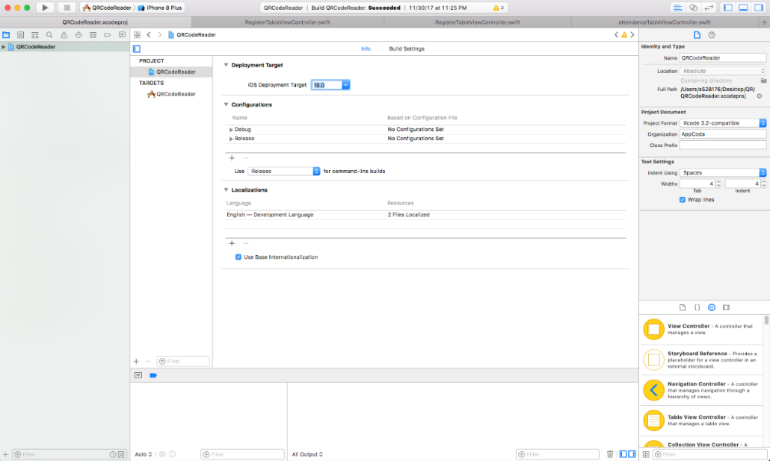

Plug your mobile to the MAC system and keep the mobile unlocked.

## Before you proceed into installing the iOS application on your mobile, please follow the below steps.

## Click on the QRCodeReader below Targets and Change the **bundle identifier** to a unique string “aabbcc”.C:\Users\s528176\Desktop\InkedScreen Shot 2017-12-06 at 7.38.09 PM_LI.jpg

Now, click on Team and add an account. This account will be your iTunes id and password.

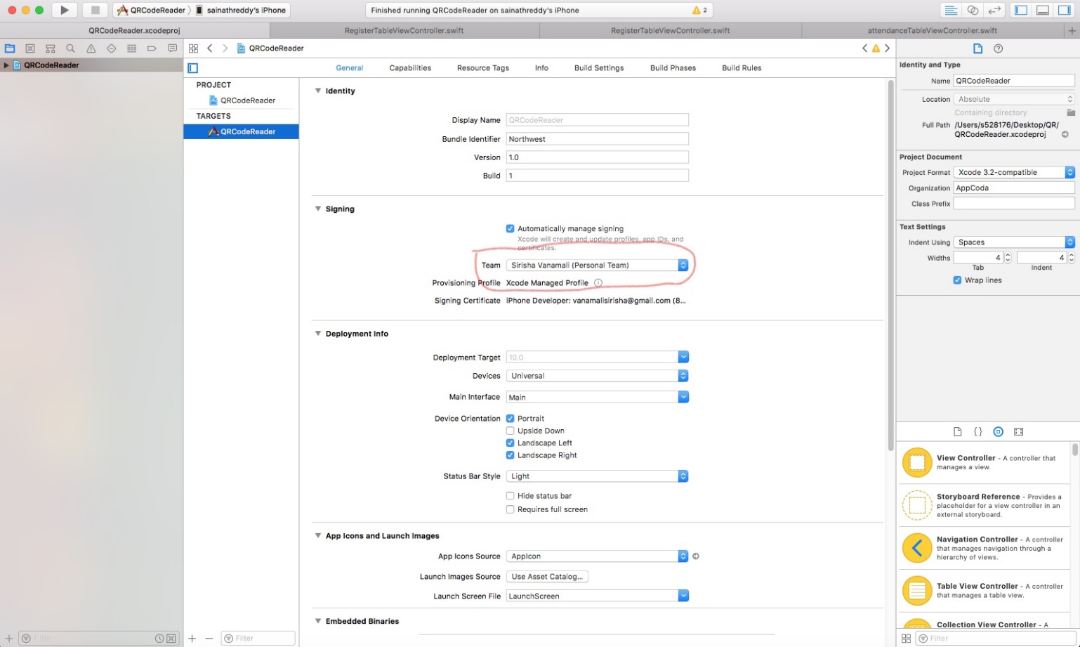

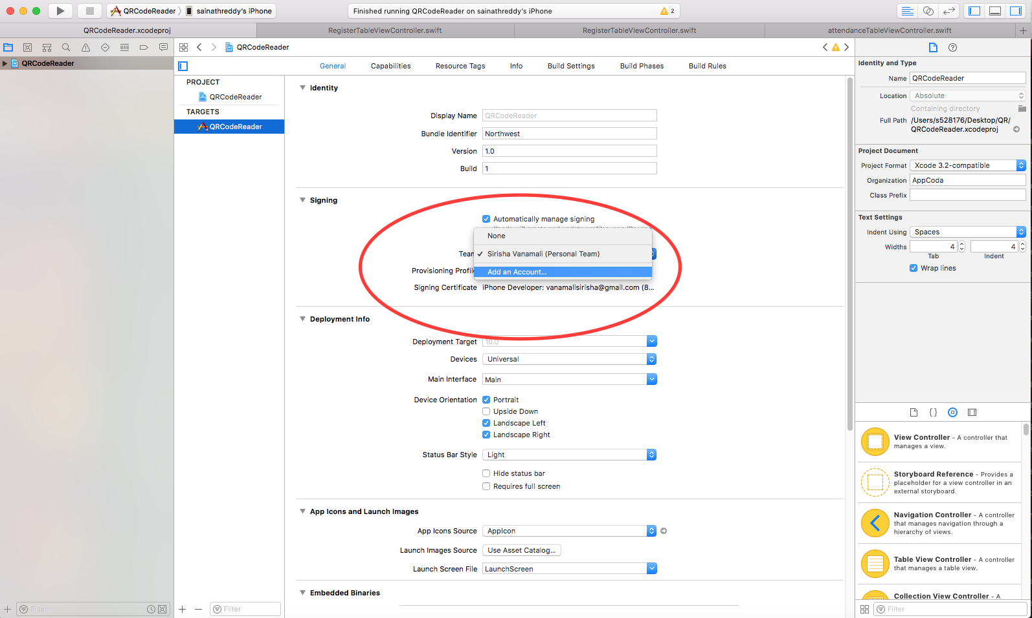

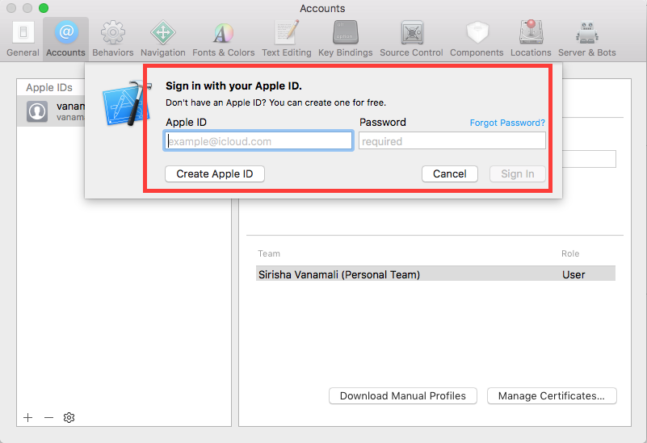

Click on the red highlighted area and choose your Iphone mobile( Yourname+ Iphone(unavailable). This is usually the first option on the selections right on the top of the list.

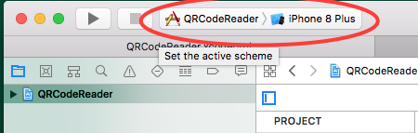

I’m installing the application on Sainath’s mobile. So below is what it looks like and I selected it by clicking on it.

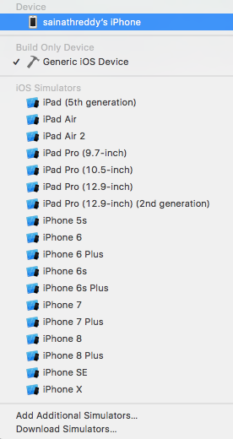

Sometimes, the debugger support is run on the application, which might take a while to finish. Wait till it finishes its tasks.

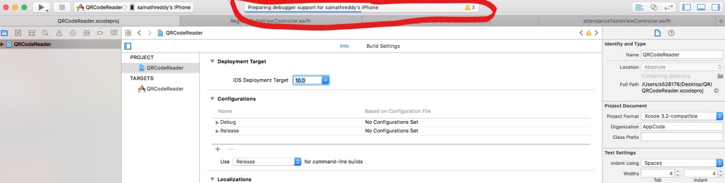

Once the status says “Build QRCodeReader: Succeeded“ on the top center, Click on run button on the top left corner which looks like play button on a vlc media player.

C:\Users\s528176\Downloads\attachments\Screen Shot 2017-12-06 at 7.46.13 PM.png

The application will now open on your mobile. Register before you login.

Go to mobile settings, open General-> DeviceManagement ->Trust the QRCODEREADER application.

The application now opens itself. Register before you login.